

**NOTICE**

# GUIDELINES FOR FINAL YEAR STUDENTS REGARDING INDUSTRIAL INTERNSHIP / PROJECT (IDP / UDP)



GTU guidelinesfor Industrial Internship

1. It shall be of minimum duration of 12 week.
2. Student has to finalize the Internship /Project within first 2 weeks.
3. They have submit all details regarding Internship/Project on PMMS portal within time limit specified by GTU.
4. A student has to submit a brief proposal about the work to be carried out, in the internship, to respective mentors within 3 weeks, after starting the internship.
5. The internship shall be a full time for the whole duration.
6. A detailed daily diary is supposed to be maintained by student. It shall be signed duly by the concerned supervisor of industry. It shall be submitted to the department. (**Refer attachment for sample format of daily log.)**
7. A plan for the whole internship duration shall be prepared after joining the industry after consultation with the supervisor/mentor/guide of industry. It shall contain the activities/ visits to different sections etc with appropriate timelines.
8. A comprehensive report is required to be prepared and submit to the department at the end of the semester. A certificate shall be attached with this report duly signed by the competent authority of the industry for the successful completion of the internship. An attendance report shall also be attached with this report.
9. The internal evaluation shall be done at the start of the semester, at the mid of the semester and at the end of the semester. The internal marks shall be divided as decided by the head.

The time schedule for internal evaluation will be as follows.

## 1st evaluation in last week of February

* 1. **2nd evaluation in last week of March.**
  2. **3rd and final evaluation in last week of April.**

**The detailed time table will be provided by respective department.**

1. An attendance report shall be sent to the department after every four weeks.
2. The student should record the day to day observations, impressions, information gathered and suggestions given, if any in the weekly diary. It should contain the related sketches and drawings. **The format of weekly dairy is attached herewith as Annexure-1**
3. The project report shall be submitted to the institute which may include the objective of training, about the industry, process, product line, equipment/machineries involved, divisions/sections in the industry, any competitor, scope of some improvement in the process/product/efficiency, benefit by the training etc. A certificate shall be attached with this report duly

signed by the competent authority of the industry for the successful completion of the internship. An attendance report shall also be attached with this report.

1. At the end of Internship student has to submit following documents forthe duration of internship.
   1. Daily log
   2. Weekly log –**Annexure-1**
   3. Attendance record.
   4. Internship Permission letter.
   5. Feedback from industry expert **as per Annexure-II**
   6. Final Project report as per the GTU format.
   7. Other documents asked by GTU.

**Annexure 1 Enrollment no:**

**NAME OF STUDENT:**

**DIARY OF THE WEEK: Dt: TO DEPARTMENT: SEM:**

**NAME OF THE ORGANISATION: NAME OF THE PLANT/SECTION/DEPARTMENT: NAME OF OFFICER INCHARGE OF THE PLANT/SECTION/DEPARTMENT: _**

**DESCRIPTION OF THE WORK DONE IN BRIEF**

(ગજુ રાત અધિધિયમ ક્રમાકા ં : ર૦/ર૦૦૭ દ્વારા સ્થાધિત)



**TOTAL HOURS:**

**SIGNATURE OF STUDENT**

**The above entries are correct and the grading of work done by Trainee is EXCELLENT / VERY GOOD / GOOD / FAIR / BELOW AVERAGE / POOR**

**Signature of Faculty Mentor**

**Signature of officer-in-charge**

**of Dept. / Section / Plant**

**Date:**

**Date:**

**Grading of Work, for trainee may be given depending upon your judgement about his Punctuality, Regularity, Sincerity, Interest taken, Work done etc.**

((ગજુ રાત અધિધિયમ ક્રમાકા ં : ર૦/ર૦૦૭ દ્વારા સ્થાધિત)

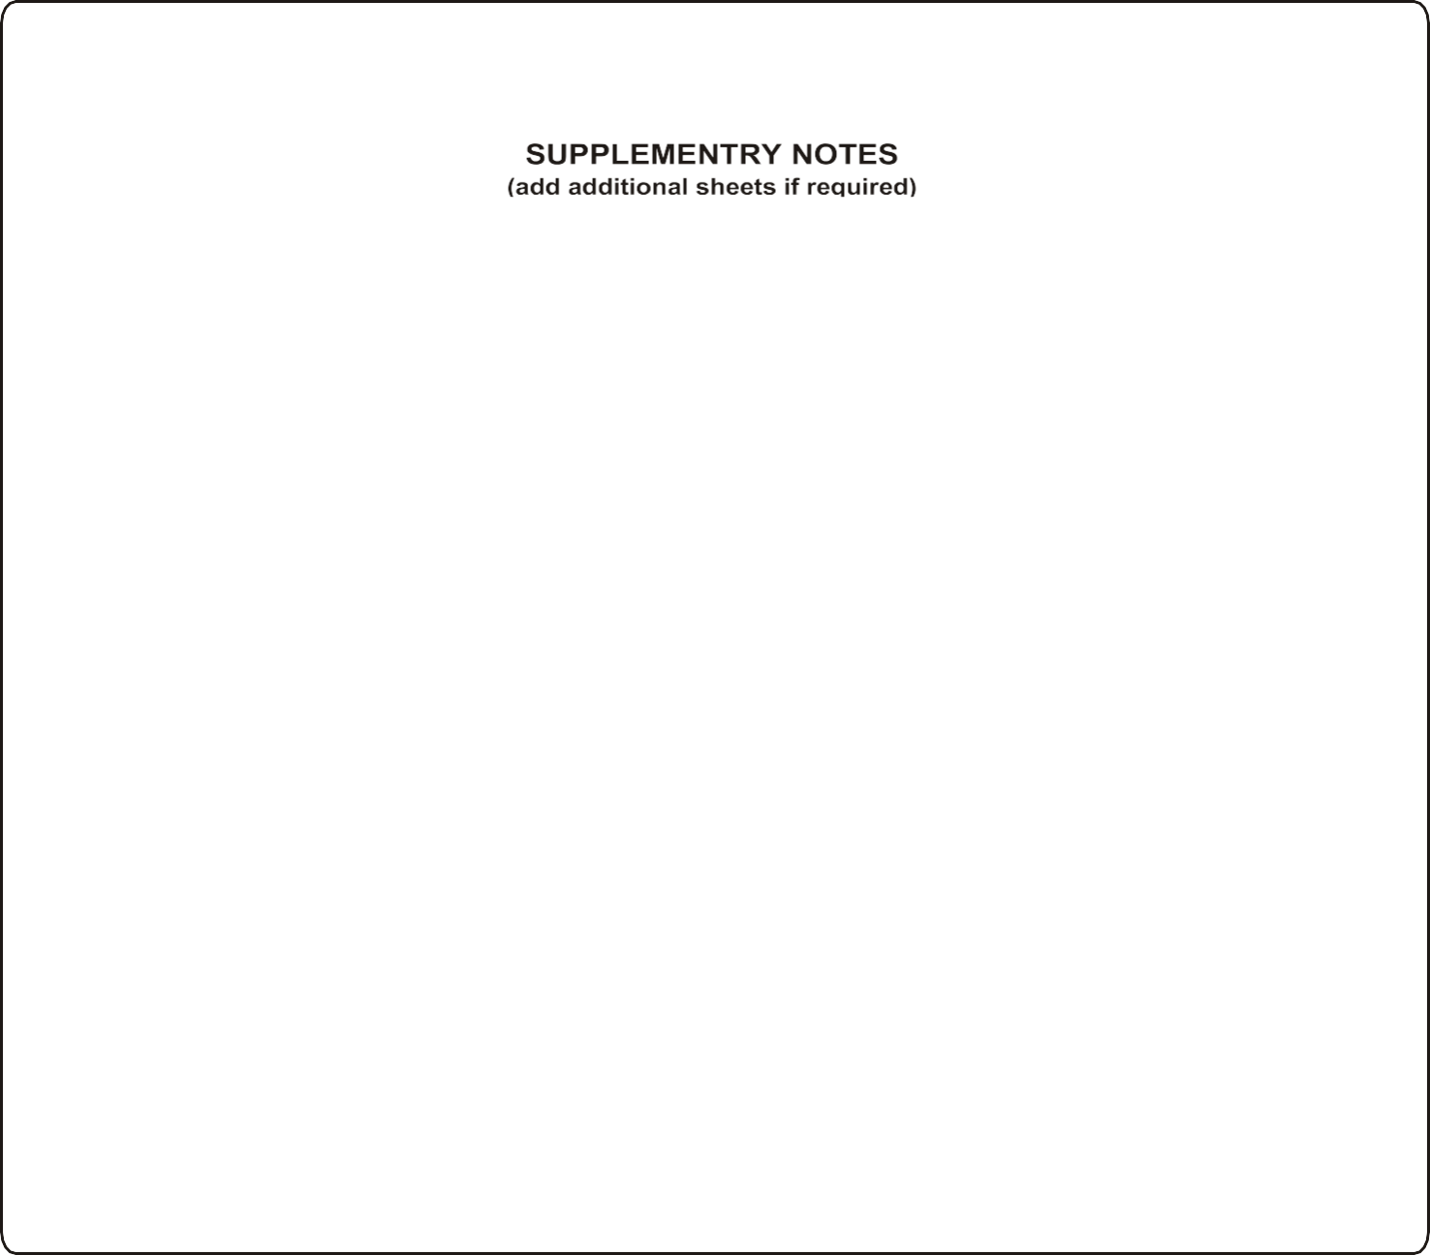

**GUJARAT TECHNOLOGICAL UNIVERSITY**

**(Established under Gujarat Act No. 20 of 2007)**

**ગુજરાત ટેકનોલોજીકલ યુનનવનસિટી**

(ગજુ રાત અધિધિયમ ક્રમાકા ં : ર૦/ર૦૦૭ દ્વારા સ્થાધિત)

|  |  |  |
| --- | --- | --- |
|  | | **Annexure 2** |
| **Feedback Form by Industry expert**  Student Name: |  | Date: |
| Work Supervisor: |  | Title: |
| Company/Organization: |  |  |
| Enrollment No: |  |  |
| Internship Address: |  |  |
| Dates of Internship: From | to |  |

Please evaluate your intern by indicating the frequency with which you observed the following behaviors:

|  |  |  |  |  |
| --- | --- | --- | --- | --- |
| Parameters | Needs improvement | Satisfactory | Good | Excellent |
| Shows interest in work and his/her initiatives |  |  |  |  |
| Produces high quality work and accepts responsibility |  |  |  |  |
| Uses technical knowledge and expertise |  |  |  |  |
| Analyzes problems effectively |  |  |  |  |
| Communicates well and writes effectively |  |  |  |  |

Overall performance of student intern: (Needs improvement/ Satisfactory/Good/Excellent):

Additional comments, if any:

Signature of Industry person with name and Stamp:

Signature of the Faculty Mentor

**STUDENT’S DAILY DIARY/ LOG**

**Name of student:**

|  |  |  |  |  |
| --- | --- | --- | --- | --- |
| **Date** | **Day** | **Name of completed Task** | **Work of the day** | **Sign of the Industry**  **supervisor** |
|  |  |  |  |  |
|  |  |  |  |  |
|  |  |  |  |  |
|  |  |  |  |  |
|  |  |  |  |  |